# A Smoother Way to Sign In – Welcome to Visma Connect!

Visma Connect IdP makes logging in to all Visma systems easy and secure through a single sign-on (SSO) experience. The service works seamlessly across web, mobile, and other applications, connecting both on-premises and cloud-based solutions.

To protect login credentials and sensitive data, Visma Connect leverages industry-standard protocols such as OpenID Connect 1.0, OAuth 2.0, and SAML 2.0. This ensures robust security without compromising ease of use. Additional benefits include:

### **🔒 Continuous Security Updates – With Zero Effort on Your Part**

* Visma Connect handles ongoing security updates automatically, keeping you protected against emerging threats without any manual intervention.
* The system is continuously developed to align with the latest security standards, ensuring your login processes remain resilient and up to date.

### **🔑 Smarter, Safer Authentication with Modern Methods**

* Support for biometric authentication methods like Face ID and Touch ID, as well as BankID, offers users a more secure and streamlined way to log in.
* By removing the need for manually entered passwords, the risk of credential theft and phishing attacks is significantly reduced.

### **🛠️ Fewer Login Issues and Reduced Support Tickets**

* Biometric login and BankID eliminate common password problems.
* Fewer forgotten passwords mean less user frustration and a lower volume of support requests – saving time and resources for your organization.

### **⚡ One Login Across Multiple Systems**

* If you're using several Visma services, login becomes seamless across the entire ecosystem. Users no longer need to manage separate credentials for different Visma products.
* And if you're only using a single Visma solution today, Visma Connect ensures you're future-ready – new integrations can be added without additional setup.

# How the Transition Works

To ensure a smooth and secure transition to Visma Connect, the switch takes place in two phases: preparation and activation.

### **1. Preparation – User Provisioning**

Before Visma Connect becomes the active login method, all users need to be provisioned in the system. This means:

✅Users verify their email address.  
✅Visma Connect accounts are automatically created and linked to existing HRM users.  
✅Users can set a password for their Visma Connect account.

This step does not affect the current login process.

### **2. Transition – Activating Visma Connect**

Once everything is set up, Visma Connect will be activated as the new login solution. From this point on, users will sign in using Visma Connect instead of the previous method.

#### **What does this mean for users?**

* The login screen will have a new look and feel.
* Users must log in with the email address they verified during the provisioning phase.
* If a user hasn’t set a password before activation, they can do so the first time they log in by clicking **“Forgot your password?”**
* Users who did not complete the provisioning step during the preparation phase will be unable to log in once the transition is complete

After the transition, Visma Connect becomes the default login for Flex HRM, and the old login method will no longer be available.

### **What does this mean for you as an administrator?**

* In most cases, users provision themselves – no action is required from you.
* If a user was absent or unable to complete their own provisioning during the preparation phase, you can provision them manually after the transition.

# User Journey (Desktop)

1. During the provisioning period, users will see a banner displayed at the top of all pages in Flex HRM until they link their user to a Visma Connect account. The banner prompts the user to prepare their account by going to Account Settings.

|  |
| --- |

2. Under My Profile > Account Settings, the following banner is displayed which prompts the user to enter and verify their email address:

|  |
| --- |

3. The user can select one of the suggested email addresses or enter a different email address. The email addresses that are suggested are those that are saved on the user or the employment with mailings activated.

|  |
| --- |

4. When the user has selected or entered an email address, they can click the button to send an email with a verification code to the specified address.

|  |
| --- |

5. The user will receive the following email:

|  |
| --- |

6. The user should now go back to Account Settings in Flex HRM, enter the code in the code field and click on the “Verify” button.

|  |
| --- |

7. Now the user is connected to Visma Connect and thus fully provisioned. The user can at this stage choose to create a password for the account through Visma Connect Account Settings.

|  |
| --- |

# Create a password before the transition

# FAQ

### An employee was absent during provisioning and cannot log in now that we have switched to Visma Connect, what do we do now?

An administrator with authorization to the Users view can enter an email address and send a verification message to the user. The user will now receive a link to click on to verify their email address.

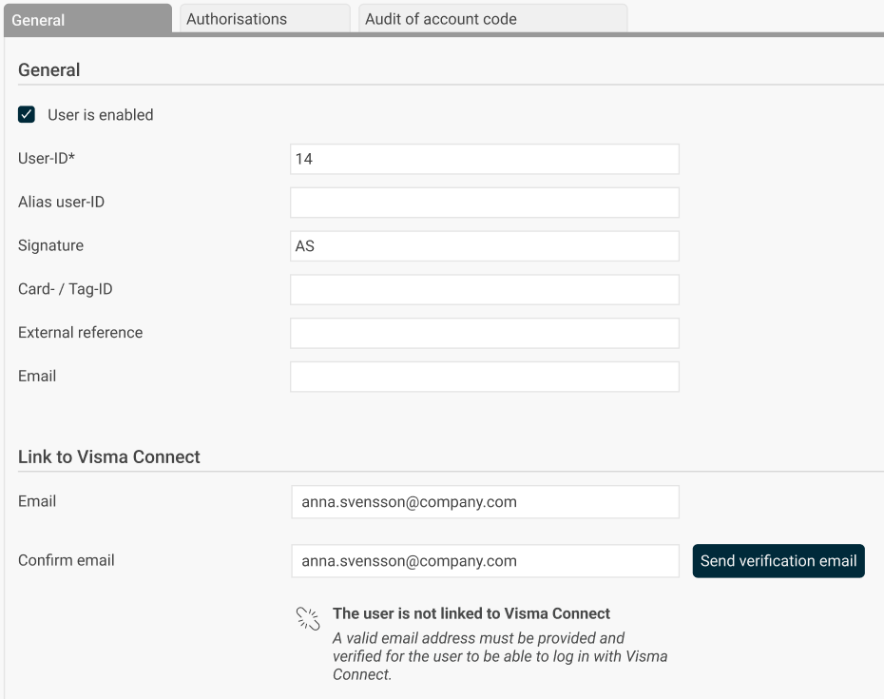

When the user has verified their email address, the user is linked to Visma Connect.

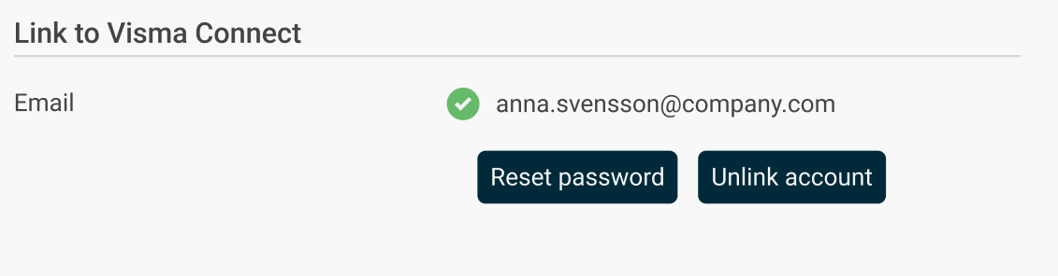

After that, the user can create a password through "Forgot your password?" on the login page.

### 

### An employee has used a private email address instead of the company's to link their HRM user to Visma Connect, how do we change it?

1. **Remove the connection**

An administrator with authorization to the "Users" view must first delete the current Visma Connect connection.

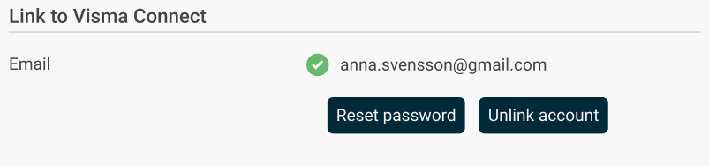

1. **Connect a different email address**

* If you are still in the provisioning period (preparation phase), the user will again see a banner at the top of Flex HRM when the link is removed. The user can then go to My Profile > Account Settings and redo the link with the correct email address.
* If you are already using Visma Connect for login, the administrator can update the email address manually:
  + Enter the new email address for the user in the "Users" view.
  + Send a new verification email to the new address.

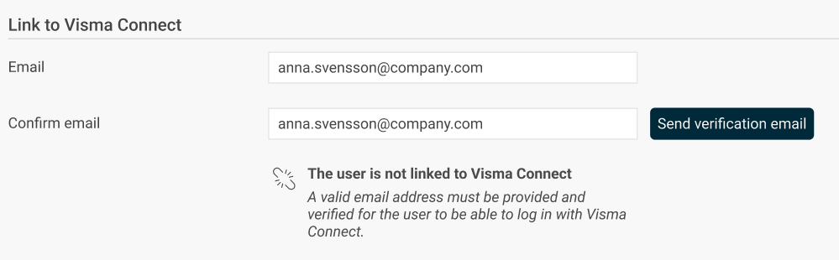

1. **Complete the connection**

The user clicks on the link in the verification email to confirm the email address.

### We want all employees to use only their email addresses ending with '@company.com' when connecting their HRM user to Visma Connect. How can we enforce this restriction?

You can find a new section for specifying allowed domains for connecting to Visma Connect by navigating to the General > Security page. This is where you can list the domains you wish to permit.

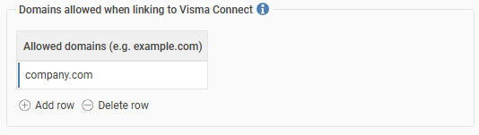

It's crucial to configure the allowed domains before the preparation phase begins, as this setting will not affect users who are already connected. If no domains are specified, all domains will be allowed during email verification and, consequently, the connection to Visma Connect.  
  
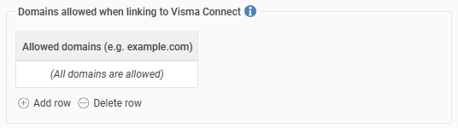

We want to be able to import and export email addresses. Is this possible?

Yes, it is!

The field "Email Visma Connect" is now available to choose in import and export templates of type "Employees/users". If an invalid email address is entered, the field will not be updated.

Note that it is only possible to import emails for users not linked to Visma Connect.